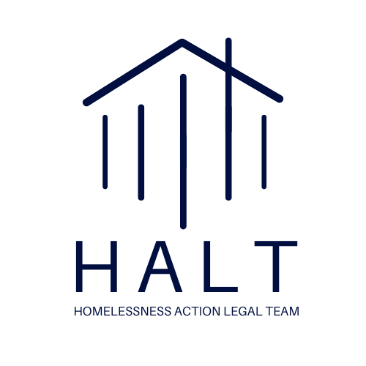

**2023 HALT MEMBERSHIP FORM**

Name_______________________________________________________

Title_________________________________________________________

Law Firm/Company___________________________________________________

Street Address_________________________________________________________

City______________________________ State____________ Zip Code__________________

Phone(____)____________________________Email____________________________________________

Pro Bono Contact (if different from above) _____________________________________________

**2023 Membership Levels & Benefits:**

[] **Champion: $15,000 and above.** All benefits included at the Partner level, plus tailored pro bono opportunities; opportunity to co-brand reports and webinars with the Law Center; six tickets to attend and recognition at the annual Human Right to Housing Awards.

[] **Partner: $10,000 to $14,999**. All benefits included at the Member level, plus priority selection of high-impact pro bono opportunities, increased recognition as a Partner, and four tickets to the annual Human Right to Housing Awards.

[]**Member: $7,500 to $9,999.** Participation in our newly launched think tank, recognition throughout the year in NHLC’s newsletters, website, social media, reports, and other relevant publications; invitations to HALT networking events; two tickets to the annual Human Right to Housing Awards.

If your firm is 50 attorneys or less, please contact our Pro Bono Director, [cmartin@homelesslaw.org](mailto:cmartin@homelesslaw.org), for more information.

My firm’s check for $ ________________________________($7,500 minimum)

Please make check payable to National Homelessness Law Center and mail to address below.

**Contact:** **Jennifer Toth Clary, Development Director, jclary@homelesslaw.org or** org or 202-638-2535 ext. 118

NHLC is a 501(c)(3) not-for-profit organization. Contributions are tax

deductible.

**Board of Directors**

**Eric A. Bensky**

*Chair*

Murphy & McGonigle PC

**Julia M. Jordan**

*Vice-Chair*

Sullivan & Cromwell LLP

**Robert C. Ryan**

*Treasurer*

American Red Cross

### 

### Kirsten Johnson-Obey *Secretary*

### NeighborWorks

**Mark Baugh**

Baker Donelson

**Mary Benton**

Alston & Bird LLP

**Paul F. Caron**

Microsoft Corporation

### 

**Rajib Chanda**

Simpson Thacher & Bartlett LLP

**Pamela Fessler**

NPR (retired)

**Dwight A. Fettig**

Porterfield, Fettig & Sears LLC

### Deborah Greenspan

### Blank Rome LLP

### Georgia Kazakis

Covington & Burling LLP

**Angie Garcia Lathrop**

Bank of America

### Pamela Malester

### U.S. HHS (retired)

**Josephine McNeil**

CAN-DO

### Matthew Murchison

### Latham & Watkins LLP

### Jacqueline O’Garrow

Bank of America (retired)

### G.W. Rolle

Missio Dei Church

### Jeffrey A. Simes

Goodwin Procter LLP

**Franklin Turner**

McCarter & English LLP

**Suzanne Turner**

Dechert LLP

**Robert Warren**

People for Fairness Coalition

**Jill Williams**

US Coast Guard (retired)

**Khadijah Williams**

Rocketship Public Schools  
  
**Ron Zollman**Boomi, LP

### Antonia K. Fasanelli

Executive Director

*Affiliations for identification*

*purposes only*