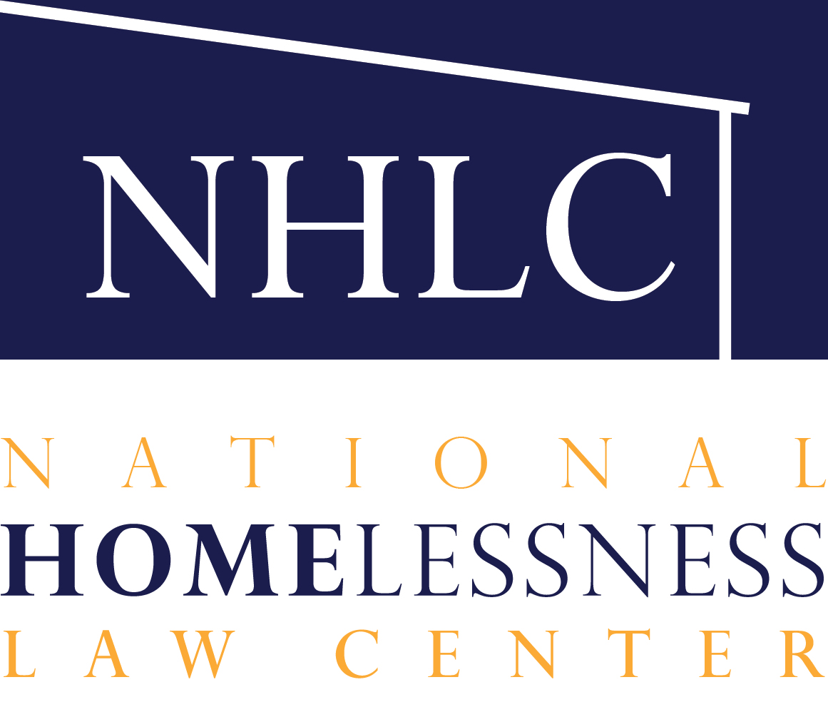
March 24, 2021

To: Chris.Paddie@house.texas.gov <Chris.Paddie@house.texas.gov>; Ana.Hernandez@house.texas.gov<Ana.Hernandez@house.texas.gov>; Joe.Deshotel@house.texas.gov <Joe.Deshotel@house.texas.gov>; Sam.Harless@house.texas.gov <Sam.Harless@house.texas.gov>; Donna.Howard@house.texas.gov<Donna.Howard@house.texas.gov>; todd.hunter@house.texas.gov <todd.hunter@house.texas.gov>; phil.king@house.texas.gov <phil.king@house.texas.gov>; eddie.lucio_iii@house.texas.gov<eddie.lucio_iii@house.texas.gov>; will.metcalf@house.texas.gov <will.metcalf@house.texas.gov>; richard.raymond@house.texas.gov <richard.raymond@house.texas.gov>; Matt.Shaheen@house.texas.gov<Matt.Shaheen@house.texas.gov>; Shelby.Slawson@house.texas.gov <Shelby.Slawson@house.texas.gov>; john.smithee@house.texas.gov <john.smithee@house.texas.gov>
Cc: John.Buxie@house.texas.gov <John.Buxie@house.texas.gov>; Paige.Bufkin@house.texas.gov<Paige.Bufkin@house.texas.gov>; Christian.Manuel@house.texas.gov <Christian.Manuel@house.texas.gov>; Ron.Hickman@house.texas.gov <Ron.Hickman@house.texas.gov>; Jacob.Cottingham@house.texas.gov<Jacob.Cottingham@house.texas.gov>; angie.flores@house.texas.gov <angie.flores@house.texas.gov>; ashley.westenhover@house.texas.gov <ashley.westenhover@house.texas.gov>; Sergio.cavazos@house.texas.gov <Sergio.cavazos@house.texas.gov>; daniel.giese@house.texas.gov<daniel.giese@house.texas.gov>; Antonio.Mireles@house.texas.gov <Antonio.Mireles@house.texas.gov>; Caitlin.Dempsey@house.texas.gov <Caitlin.Dempsey@house.texas.gov>; Andrea.Stingley@house.texas.gov<Andrea.Stingley@house.texas.gov>

Via email

Hello,

I write on behalf of the National Homelessness Law Center (“Law Center”) to oppose HB 1925 which would prohibit sheltering in public statewide regardless of access to indoor shelter alternatives, disability status, or inclement weather conditions. This punitive and overly broad bill would also require that all local actors enforce the state-imposed ban, regardless of local policy factors, or face the loss of state grant funds. This bill is inhumane, harmful to communities, and may expose the State of Texas to expensive and divisive litigation. It is also incorrectly aimed at punishing unhoused people for lacking shelter when unsheltered homelessness can more affordably and sustainably be solved with proven housing and service solutions. We urge you to vote no on HB 1925.

The Law Center is based in Washington, D.C., and we are the only national legal organization dedicated solely to preventing and ending homelessness. We have over 30 years of experience in policy advocacy, public education, and impact litigation related to housing and homelessness. Since 2006, the Law Center has tracked laws criminalizing homelessness in 187 cities across the country, and we have documented the failures, harms, and costs of those policies in numerous national reports, including Housing Not Handcuffs 2019: Ending the Criminalization of Homelessness in U.S. Cities (2019) available at http://nlchp.org/wp-content/uploads/2019/12/HOUSING-NOT-HANDCUFFS-2019-FINAL.pdf.

In addition to raising awareness about the criminalization of homelessness, we have filed lawsuits to challenge policies that punish homeless people for acts of survival in public space when they lack adequate alternatives. One of our cases, Martin v. City of Boise, resulted in a decision from the Ninth Circuit holding that the Eighth Amendment of the U.S. Constitution prohibits enforcement of laws criminalizing universal resting activities performed in public space by people with no access to indoor shelter. Similar precedent in Johnson v. City of Dallas is binding in the Fifth Circuit, where Texas resides.

Punishing unhoused people for lacking housing does not reduce the number of people who sleep outside and shelter themselves for survival. To the contrary, the collateral consequences of criminal convictions make housing and employment difficult to obtain, which undermines efforts to end homelessness. Moreover, numerous studies, including those documented in the report linked above, demonstrate that governments waste tax dollars in enforcing these ineffective and harmful policies to no constructive end. Those same studies also demonstrate the cost-effectiveness of investing in housing solutions to homelessness.

To achieve the goal of reducing and eliminating homelessness, focus on access to permanent housing and interim locations where unhoused people can stably live with dignity. Housing ends homelessness, and the report linked above provides examples of communities that have successfully reduced their outdoor homeless population by investing in what works.

We urge you to vote no on the old, failed, harmful, legally suspect, and expensive strategy of punishing homelessness set forth in HB 1925.

Sincerely,
Tristia Bauman

